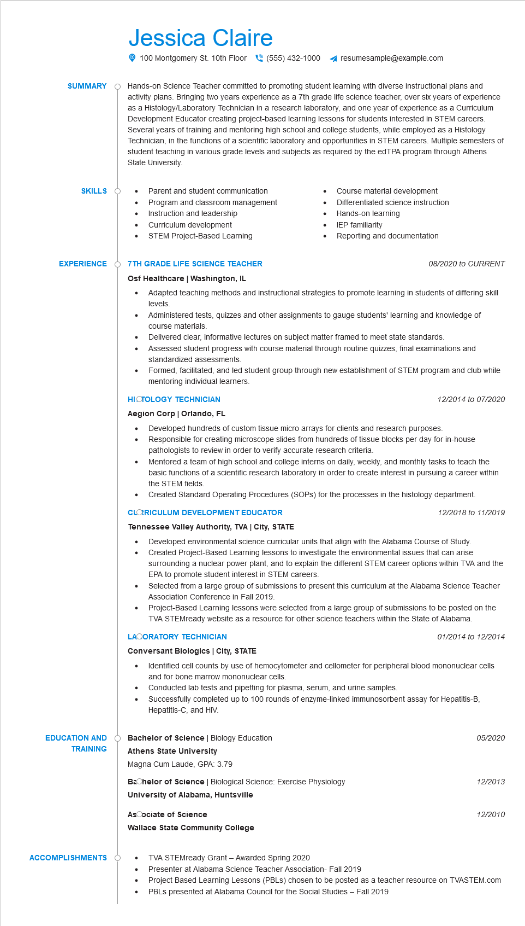
SUMMARY
Jessica Claire
100 Montgomery St. 10th Floor(555) 432-1000 ◄ resumesample@example.com
Hands-on Science Teacher committed to promoting student learning with diverse instructional plans and activity plans. Bringing two years experience as a 7th grade life science teacher, over six years of experience as a Histology/Laboratory Technician in a research laboratory, and one year of experience as a Curriculum Development Educator creating project-based learning lessons for students interested in STEM careers. Several years of training and mentoring high school and college students, while employed as a Histology Technician, in the functions of a scientific laboratory and opportunities in STEM careers. Multiple semesters of student teaching in various grade levels and subjects as required by the edTPA program through Athens State University.
SKILLS
EXPERIENCE
• Parent and student communication Program and classroom management Instruction and leadership
•
Curriculum development
STEM Project-Based Learning
O 7TH GRADE LIFE SCIENCE TEACHER Osf Healthcare | Washington, IL
Course material development
Differentiated science instruction
Hands-on learning
•
IEP familiarity
Reporting and documentation
08/2020 to CURRENT
Adapted teaching methods and instructional strategies to promote learning in students of differing skill levels.
Administered tests, quizzes and other assignments to gauge students' learning and knowledge of course materials.
Delivered clear, informative lectures on subject matter framed to meet state standards.
•
•
Assessed student progress with course material through routine quizzes, final examinations and standardized assessments.
Formed, facilitated, and led student group through new establishment of STEM program and club while mentoring individual learners.
HISTOLOGY TECHNICIAN
Aegion Corp | Orlando, FL
12/2014 to 07/2020
Developed hundreds of custom tissue micro arrays for clients and research purposes.
· Responsible for creating microscope slides from hundreds of tissue blocks per day for in-house pathologists to review in order to verify accurate research criteria.
Mentored a team of high school and college interns on daily, weekly, and monthly tasks to teach the basic functions of a scientific research laboratory in order to create interest in pursuing a career within the STEM fields.
Created Standard Operating Procedures (SOPs) for the processes in the histology department.
CLORICULUM DEVELOPMENT EDUCATOR
Tennessee Valley Authority, TVA | City, STATE
12/2018 to 11/2019
Developed environmental science curricular units that align with the Alabama Course of Study. Created Project-Based Learning lessons to investigate the environmental issues that can arise surrounding a nuclear power plant, and to explain the different STEM career options within TVA and the EPA to promote student interest in STEM careers.
Selected from a large group of submissions to present this curriculum at the Alabama Science Teacher Association Conference in Fall 2019.
Project-Based Learning lessons were selected from a large group of submissions to be posted on the TVA STEMready website as a resource for other science teachers within the State of Alabama.
LAOORATORY TECHNICIAN
Conversant Biologics | City, STATE
•
01/2014 to 12/2014
Identified cell counts by use of hemocytometer and cellometer for peripheral blood mononuclear cells and for bone marrow mononuclear cells.
•
Conducted lab tests and pipetting for plasma, serum, and urine samples.
•
Successfully completed up to 100 rounds of enzyme-linked immunosorbent assay for Hepatitis-B, Hepatitis-C, and HIV.
EDUCATION AND
Bachelor of Science | Biology Education
05/2020
TRAINING
Athens State University
Magna Cum Laude, GPA: 3.79
Bachelor of Science | Biological Science: Exercise Physiology
12/2013
University of Alabama, Huntsville
AsCociate of Science
12/2010
Wallace State Community College
ACCOMPLISHMENTS
TVA STEMready Grant - Awarded Spring 2020
Presenter at Alabama Science Teacher Association- Fall 2019
Project Based Learning Lessons (PBLS) chosen to be posted as a teacher resource on TVASTEM.com PBLs presented at Alabama Council for the Social Studies - Fall 2019

